At Christmas… all roads lead home.
- Premier TR300MIX

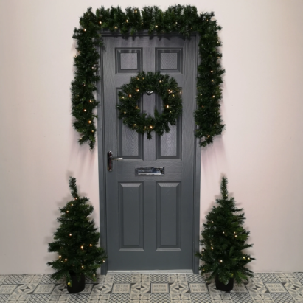
Make your home just gorgeous with this Pre-lit Christmas Door Set. Premier TR300MIX
This fabulous set comes with:
- 2 x 90cm pre-lit trees with 35 warm white LEDS per tree.
- 1 x 2.7m pre-lit garland with 35 warm white LEDS.
- 1 x 60cm pre-lit wreath with 25 warm white LEDS.
- Timer function:
  - The product also comes with a timer function so from when you first turn the product on it will stay on for 6 hours and then automatically turn of and come back on 18 hours later at the same time you turned them on the day before.
- Flame retardant.
- Quick and easy assembly.
- Batteries not included (12 x AA batteries overall – 3 for each item)
- For indoor and outdoor use.
- The bulbs in this product are non-replaceable.
Price: €99
- Noma 2114022
It's not just a Christmas tree… it's a beacon for Santa!

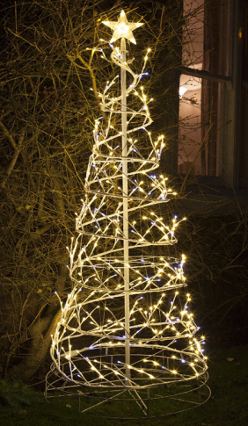

We stock a wide large range of light up Christmas Decorations that will transform your garden and home into a stunning festive scene, choose a Spiral Tree from three different colours:

- Warm White, Cool White or Multi-coloured.
- Mix of static and twinkling LEDs.
- Includes Ground Pegs.
- 10m Lead cable.

Our choice of light up figures and trees are guaranteed to be the unique feature of your display. Perfect for inside or outside your home and collapsible for easy storage.
***Make sure is that the transformer is placed in a dry environment.
***We recommend using a weatherproof socket box.

Price: €159

